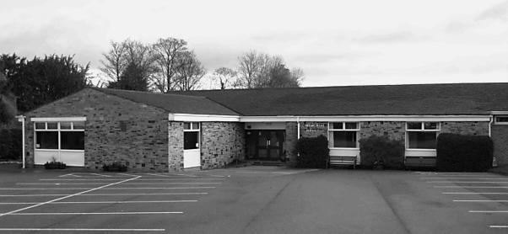
Hampsthwaite Memorial Hall
Hollins Lane
Hampsthwaite, HG3 2EJ
Reg Charity No. 523703
H.B.C. Licence No. WK/050606862

Bookings:
Email: Bookings@hampsthwaite.org.uk
Web: www.hampsthwaite.org.uk/memorialhall/
Tel: 0789 4442227

Hampsthwaite Memorial Hall : What Next?

Listed below are some ‘brainstormed’ ideas for possible future developments at the Memorial Hall.
Please note these are ideas only at this stage and there is no certainty that any of them will be achievable.
Please indicate your support or otherwise for these initial ideas as indicated.
Post completed Surveys into the box at the Memorial Hall
or Email to: survey@hampsthwaite.org.uk

Descriptions of Initial Ideas |  | Mark Score  1 = Bad Idea  4 = Good Idea
 | Create a facility for practical craft courses and activities – for example:  - back-stage facilities to help in props and scene construction for drama and similar events?  - better facilities for practical craft work generally (we have had folk building bee hives in the dining room before now!)?  - perhaps a ‘Repair Shop’ or ‘Re-Makery’ type facility (inc. a display area where some resulting products could be for sale)?  - a Men's Shed - somewhere to just meet and 'potter' or perhaps also working alongside PayBack personnel to perform village maintenance tasks or make things for the school for example?  - a general practical hobbies space for all ages?  - somewhere even an antique restoration class might be located? | 1 2 3 4  1 2 3 4  1 2 3 4  1 2 3 4  1 2 3 4  1 2 3 4
Your own ideas or comments here:

Continue over if necessary
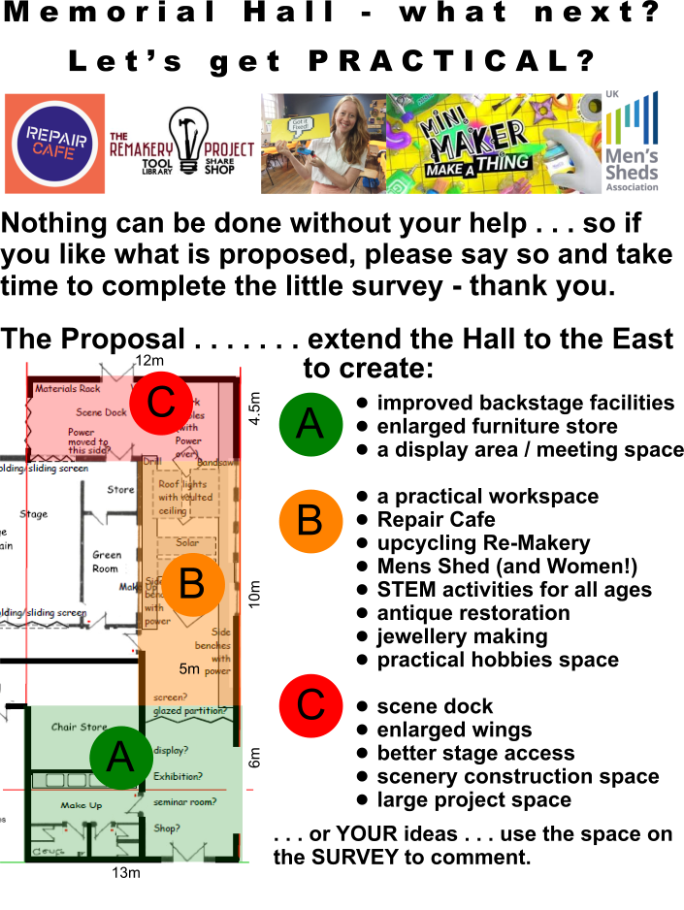
The SURVEY and further details, including links to:
Re-Makery, Repair Cafe, Mens Shed and STEM is available
on the village website at - http://www.hampsthwaite.org.uk/

